

14 October 2021

**Terra Industrial New Zealand Ltd**

PO Box 16 168

16 Branston Street, Hornby

Christchurch 8441, New Zealand

03 983 2333 tel

www.TerraCat.co.nz

**CLEARING USAGE DATA**

# Clearing all usage data

Please bear in mind that clearing all usage data will unfortunately remove all personalisations (Moved columns, columns that you have added etc, your favourites will be fine however)

1. Click File > Tools > Options

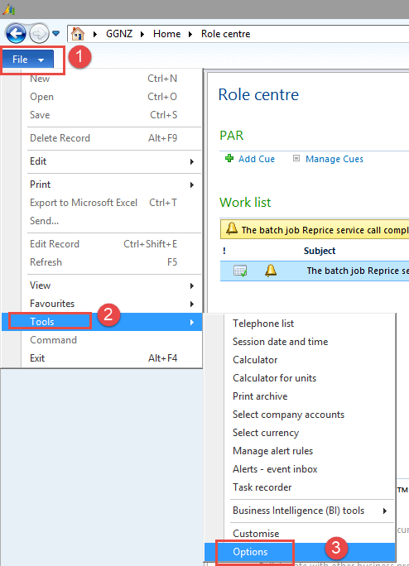

1. Click Usage Data > All Usage Data

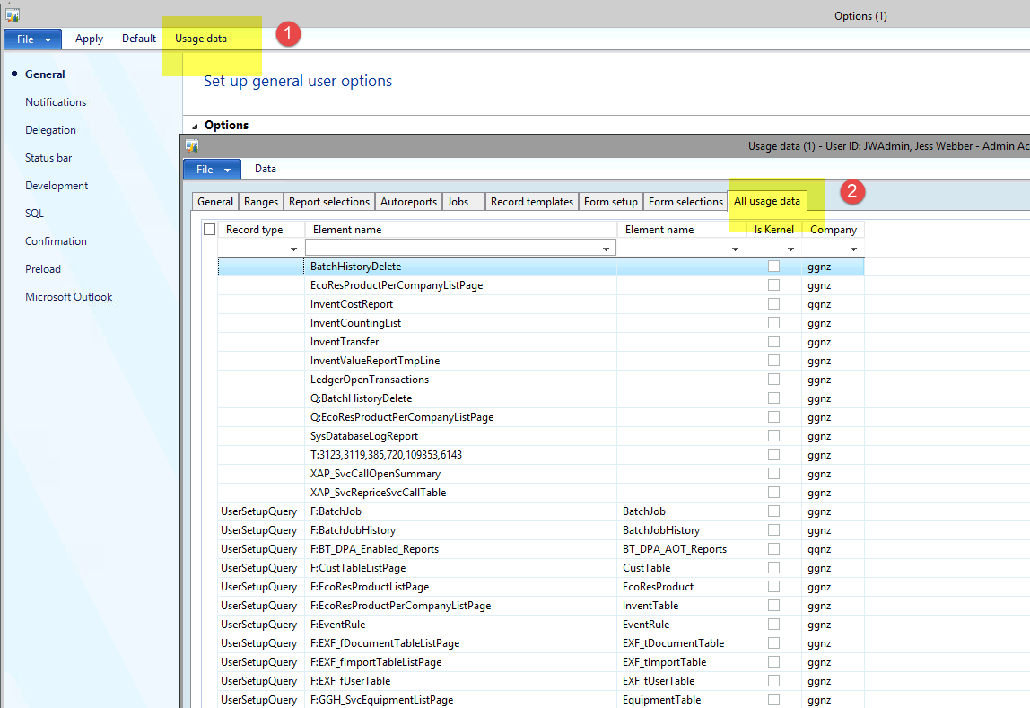

1. Tick the box to the left which will select all your usage data (making sure there are no filters in the top columns)

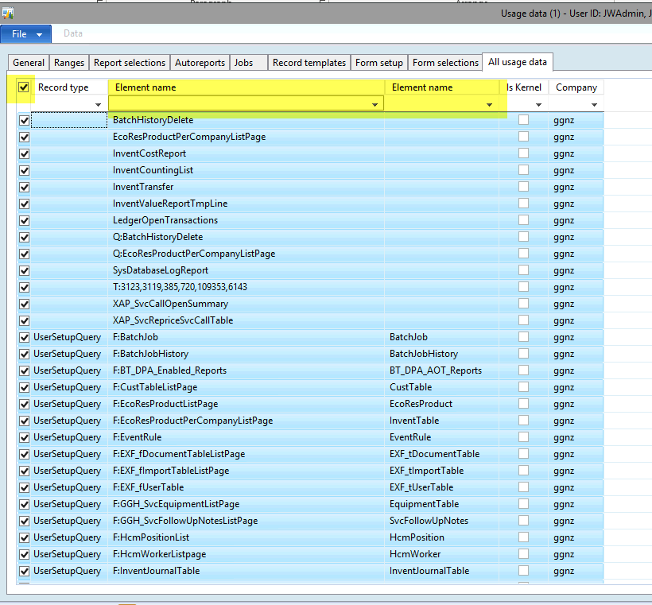

1. Click File > Delete Record

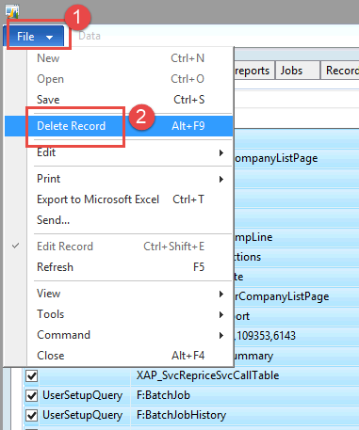

1. Click Yes

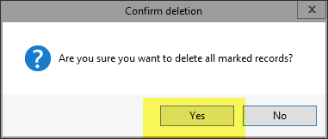

1. Now you should be able to proceed with what you were trying to do. Maybe close and reopen Naxt 😊